
4/17/2024
Evaluation Report
Bike Sharing Demand
Bike-Sharing Startup Company
Submitted By:
Elijah Shepherd

Submitted To:
Company Founder

Introduction
Background: A bike-sharing startup has just hired you as their data analyst. The business is scaling quickly, but the demand fluctuates a lot. This means that there are not enough usable bikes available on some days, and on other days there are too many bikes. If the company could predict demand in advance, it could avoid these situations.
Purpose: The project associated with this report used data consisting of the number of public bikes rented in Seoul's bike sharing system at each hour. The dataset also included information about the weather, time, & other variables such as whether it was a public holiday. Objectives of the analysis included:
- Determine if the number of bike rentals can be predicted based on other information in the dataset.
- Create predictions for how many bikes will be rented & analyze their credibility & accuracy.
The predictions & the relevant analysis are to be provided to the company & the founder.
The Data: The data used in this project pertained to the number of public bikes rented in Seoul's bike sharing system at each hour. The dataset also included information about the weather, time, & other parameters such as whether it was a public holiday. The data spanned from December 1, 2017, through November 30, 2018, which accounts for 365 days. There are 8760 observations, one for each hour of every day. There are no missing values in the dataset.
The parameters in the dataset included the date (day, month, & year), the rental bike count, hour, temperature (in degrees Celsius), humidity (as a percentage), wind speed (meters per second), visibility (in tens of meters), dew point temperature (degrees Celsius), solar radiation (Megajoules per square meter), rainfall (millimeters), snowfall (centimeters), the season, whether or not it was a holiday, & whether or not the bike-share system was operable or not ("Functioning Day").
For context, Seoul, Korea has a latitude & longitude of approximately 38 degrees north & 127 degrees east, implying that the city is in the northern hemisphere. In the data, the seasons are defined using the meteorological definitions for the northern hemisphere. Specifically, winter spanned from December 1, 2017, through February 28, 2018; spring spanned from March 1 through May 31; summer spanned from June 1 through August 31; & autumn spanned from September 1 through November 30.

Analysis
The Analysis: The first objective of the analysis was to determine if the number of bike rentals could be predicted. When preparing to create predictions, one of the first steps is determining what kind of model to use. Before making concrete predictions & finalizing them, it is important to explore different machine learning algorithms & determine which produces the best model(s) for performing predictions for this dataset. Since the most important variable to be predicted is a continuous, numerical variable, regression methods are more appropriate. Given the nature of other parameters in the data, regression methods that were explored included linear regression & random forest regression. These two techniques were used to create a model which then constructed corresponding predictions. The resulting models & their results were compared in relation to the main dataset to determine which performed better & whether any constituted credible enough & useable predictions.
As an aside, a brief skim of the data revealed that the only instances in which no bikes were rented were when the "Functioning Day" parameter was true. Since it is not the model's responsibility to define (or predict) when the bike-share system is operable, this analysis excluded these instances (& effectively this parameter) from the dataset.
Regression methods are unable to account for non-numerical data. In this case, this limitation is relevant to the date, season, & holiday parameters. To account for the date, it was split into month & day-of-week parameters. For the season & holiday parameters, the distinct values were mapped to distinct numerical values so that the regression models could account for them. These mappings were referred to by "Season Code" & "Holiday Code" in the code.
The linear regression technique was explored first because it is less complicated than the random forest technique. It is applicable to this case because it attempts to predict how a numerical value changes based on how that feature is related to other parameters. Per GeeksForGeeks.org, "linear regression is a machine learning algorithm based on supervised learning. It performs a regression task. Regression models a target prediction value based on independent variables. It is mostly used for finding out the relationship between variables and forecasting. Different regression models differ based on the kind of relationship between the dependent and independent variables they are considering, and the number of independent variables being used." Essentially, the model analyzes how a specific 'target' variable (in this case, the number of bike rentals) is related to other independent variables & attempts to model this relationship(s) as a linear equation. This relationship can be used to create predictions for this target variable. Though linear regression is a simpler regression technique, it can still provide a sufficient model for creating predictions.
On the other hand, with as many parameters as it has, the dataset may require a more complicated machine learning algorithm, such as random forest regression, for creating credible predictions. Per the Medium, "random forest is a supervised learning algorithm, meaning that the data on which it operates contains labels or outcomes. It works by creating many decision trees, each built on randomly chosen subsets of the data. The model then aggregates the outputs of all of these decision trees to make an overall prediction for unseen data points. In this way, it can process larger datasets and capture more complex associations than individual decision trees." Random forest regression is also used to predict continuous values. It is effective in working well with large datasets & capturing nonlinear relationships. This method can also deal with categorical variables which linear regression is less adept at. In contrast to linear regression, "random forest regression does not make any assumption about the underlying data distribution and can handle nonlinear relationships better. Moreover, it is less prone to overfitting due to its ability to randomly select different subsets of the data to train on and average out its results." When predicting continuous, numerical values, random forest regression is preferred over linear regression because it can have greater accuracy & prediction stability. Since such models are more complex, they can take more computational resources than linear regression.
Additionally, seasonal predictions were performed using random forest regression by splitting the dataset by season. As such, this technique eliminated the need to incorporate the season parameter into the modelling.
Aside from correlation & using typical plots, random forest regression also possesses more methods & tools in which a model can be measured & scored for accuracy. These functions were helpful in determining which of the two regression algorithms was more useful for creating credible predictions.
Both techniques produced results from their model which include predictions that correspond to actual numbers of bike rentals. Effectively, for a certain number of bike rentals, the model calculated corresponding numbers of predicted bike rentals. The parameters used to create these predictions included the hour, temperature, humidity, wind speed, visibility, dew point temperature, solar radiation, rainfall, snowfall month, day-of-week, season code, & holiday code. As such, it was clear that the dataset could be used to create predictions pertaining to the number of bike rentals. Further analysis explored how effective certain models & approaches were in creating adequate & usable predictions.
Before the regression models performed their predictions, the data was split into training & test sets. As a result, the predictions didn't entirely account for each distinct number of actual bike rentals. For example, in the original dataset, there were some instances in which two bikes were rented, but in the results of the random-forest-regression model, this same value is not present in a column of the predictions containing actual numbers of bike rentals. To determine which numbers of actual bike rentals did not have a corresponding predicted number of bike rentals, the rental counts from the original dataset were merged with these predictions containing actual numbers of bike rentals & their corresponding predicted numbers of rentals. In this merged data, any numbers of bike rentals that didn't have a corresponding predicted number of rentals (such as the example of two) had a null value in the column denoting the predicted number of rentals.
Additionally, some numbers of bike rentals had multiple distinct predicted numbers of rentals. For example, in the random-forest-regression model, the value of 62 actual bike rentals had seven different corresponding predicted numbers of rentals. These duplicate predictions & null values are of little help in trying to create predictions & understand how such predictions would perform in relation to the original data. A few different solutions were brainstormed & discussed in the project including using the predicted value of the nearest actual number of rentals with a non-null prediction, or using a range of possible predictions for rental counts with duplicate predictions.
Trying to create a single predicted number of bike rentals for every actual number of rentals is difficult for such a large dataset. Instead of trying to predict a single value, a better solution may be to predict a range of rental counts that could potentially be rented during a certain hour, a period of a day, a certain day, or some other period. The main question then becomes "what kind of range would be the most appropriate & the most effective?" Ultimately, the premise in creating these predictions is to be more precise in predicting demand, so using a smaller range of bike rental counts would be more appropriate provided that the predictions perform sufficiently well. From the original dataset, as few as two & as many as 3556 bikes were rented at any time. Therefore, optimal ranges of rentals could be split by every 10, 50, or 100 bike rentals or so. Using smaller splits could be more accurate but it would require more computational resources. To start, ranges of 50 bike rentals were split & analyzed using the results of the random forest regression model. For each range, the average number of bike rentals was calculated. This simultaneously solved the issues of missing & duplicate predictions except for ranges of bike rentals where no such number of bikes were rented at any time from the original dataset or the predictions.
This process of splitting the number of rentals into ranges & calculating averages & other statistics was done for both the original dataset & the predictions from the random forest regression model. The resulting data was used to evaluate how the predictions performed relative to the original data & determine if these predictions were effective enough to use. After determining the effectiveness of these predictions, the averaged predictions were then imputed alongside the original data to be able to use & analyze them in relation to the rest of the data. Additional performance-measuring techniques were used to check how the predictions performed. Such techniques included measuring correlation between the original & predicted number of rentals & the other parameters & plotting the original & predicted number of rentals against many of the other parameters. A point of interest from using these analytical measures was to evaluate if & how well the predictions measured up with the objectives of the analysis. Recall that the company running these bike rental services wanted to better their ability to respond effectively to fluctuating demand. These measures in the analysis helped determine if the predictions avoided recommending too many or too few rentals in relation to the observations & trends described in the original data.
Multiple python modules were used in the project including matplotlib, seaborn, plotly.express, & others. Additional details & discussions are included throughout the project.

Results
Determining Which Regression Method is Most Appropriate
The first step of the analysis included evaluating different regression models & how well their predictions performed. Then, the best method was determined & used for the rest of the analysis. As described in the previous section, linear & random forest regression were the two methods that were used. Additionally, four more random-forest models were made using seasonal subsets of the data after splitting it by season.
The results of each model provided actual numbers of bike rentals (from the original data) & corresponding predictions of rental numbers. Effectively, for a certain number of bike rentals, the model calculated corresponding numbers of predicted bike rentals. The parameters used to create these predictions included the hour, temperature, humidity, wind speed, visibility, dew point temperature, solar radiation, rainfall, snowfall month, day-of-week, season code, & holiday code. As such, it was clear that predictions can be produced for this data & the number of bike rentals using a regression model. Further analysis explored the performance & accuracy of these predictions.
The linear regression model was explored first. Linear regression can produce models with varying levels of accuracy & error depending on how complex the data is. Given that this dataset is quite large & contains many parameters, linear regression may not be able to provide the most optimal predictions. The linear regression model that was made & analyzed in the project used a test size of 0.20, meaning that 20% of the dataset was kept aside for testing purposes. The results of the predictions from the linear regression model are displayed in the figure below. The model has 1693 data points.
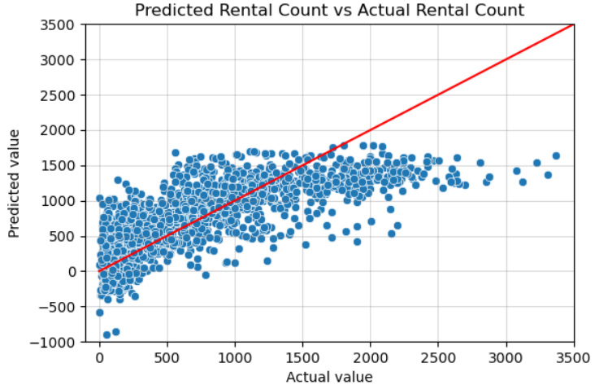
This figure depicts the predicted number of bike rentals versus the actual number of bike rentals as determined by the linear regression model. The solid red line moving from the bottom left to upper right illustrates what a positive, perfectly linear relationship looks like; one predicted bike rental for every one actual bike rental. This serves as a tool to compare the data points to & determine how the two variables are related. One of the more important features from this plot is that the model predicted negative numbers of bike rentals which is clearly impossible – there were 108 instances of a negative rental bike prediction of 1693 total predictions. This feature emphasizes how linear regression may not be the most suitable method for performing predictions on this dataset. In analyzing the plot, it is apparent that for actual bike-rental values of about 0-1000, most of the data points are above the red line. On the other hand, for actual bike-rental values of about 1500-3500, most of the data points are below the red line. This suggests that in relation to the original dataset, the predictions overestimate the number of bike rentals for smaller values (i.e. less popular rental times), & they underestimate the number of bike rentals for larger values (i.e. more popular rental times).
Additionally, three other plots displaying these predictions were made to try & fit a regression line onto the data. This was done to analyze the complexity of the relationship between the two numbers of rentals: the actual & predicted rentals. Each plot's regression line differed by order. A larger order increases the complexity of the equation that attempts to codify the relationship between the target variable & predictor variable(s). Also, a regression line with a larger order appears more complicated than lesser-order lines. These plots & their regression lines are displayed below. The data points are the same & the only difference across the plots is the green curves illustrating the regression lines.
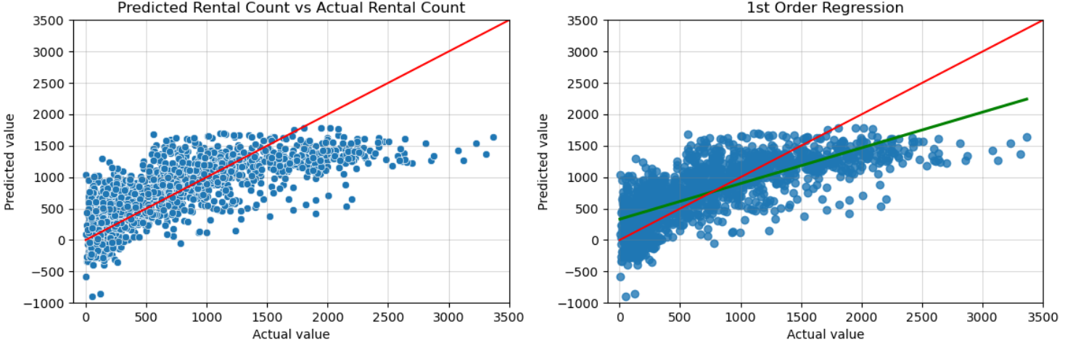
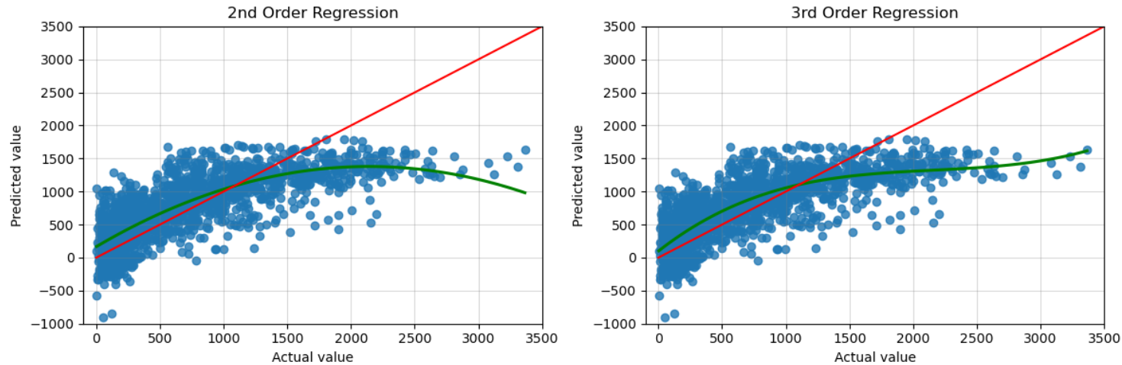
Of the three plots illustrating regression lines of differing orders, the plot with a third-order regression line appears to fit the data the best. Given that the regression line with the greatest order fits the predicted & actual data better than lines with a lesser order, linear regression may not involve enough complexity within its modelling process. As such, a different & more sophisticated method may offer greater performance in terms of predictive accuracy.
Additionally, some functions regarding performance & error metrics were used to help quantify the accuracy of the linear regression model including the mean absolute error, root mean square error, & model accuracy score. The mean absolute error is "the average variance between the significant values in the dataset & the projected values" per ScienceDirect.com. The root mean square error is "the average difference between a statistical model's predicted values & actual values" per Statistics By Jim. Smaller error values imply that the model is more accurate. The linear regression model had a mean absolute error of about 320, a root mean square error of about 420, & a model accuracy score of about 55%. Additionally, the correlation between the actual & predicted number of bike rentals was about 0.74. This value may seem strong, but it could be expected to be larger; 0.74 is far from a perfect relationship (1.0). While these numbers may not mean much on their own without additional context, the accuracy score of 55% is at least somewhat concerning. These metrics were also used to evaluate the other models, so a comparison will be able to be made to help determine which regression method is more effective.
Random forest regression is a more complicated algorithm than linear regression & may prove more suitable for this dataset given how large it is & how many parameters there are. First, a model was made from the entire original dataset using a test size of 0.25. The resulting model produced 2117 predictions whose data is plotted & shown below. Once again, the red diagonal line represents a positive, perfectly linear relationship between the horizontal & vertical axes.
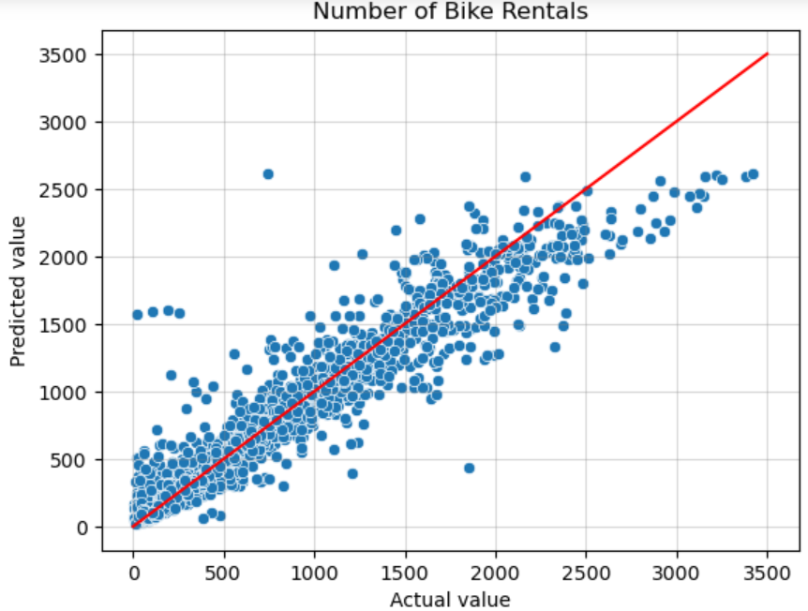
Unlike the predictions of the linear regression model, there are no negative numbers of bike rentals. On the other hand, there are similarities between the predictions of the two models regarding how they are situated relative to this red line. From about zero to 1000 actual bike rentals, most of the data points appear to be above the red line, which suggests that the model will overestimate the number of rentals at less popular rental times. Conversely, beyond 1000 bike rentals, it appears that more data points are below the red line, suggesting that the model will underestimate the number of rentals at more popular rental times.
When it comes to evaluating the performance of this random forest model, similar tests & metrics were used as for the linear model. Firstly, the actual & predicted number of bike rentals had a correlation of about 0.95. This value is significantly stronger than the 0.74 correlation coefficient from the linear model. Furthermore, the random forest model had a mean absolute error of about 120, a root mean square error of about 200, & a model accuracy score of about 90%. The values of these metrics for the linear model were about 320, 420, & 55% respectively. Across each of these four metrics, it is clear that the random forest model performs considerably better than the linear regression model. The greater accuracy score & less variance of the random forest model indicates that it is more suitable to use for predicting bike rentals than using the linear model. At this point in the project, it was decided that the random forest regression algorithm would be used moving forward.
Another useful metric which accompanies the random forest method is the ability to evaluate the importances of the features that were used as the predictor variables. A function evaluates how each feature impacts the target variable (number of bike rentals) & how important they were in predicting the target variable in the model. Essentially, this idea of feature importance measures the degree of dependency between the target & each predictor variable. The figure shown below illustrates these importances.
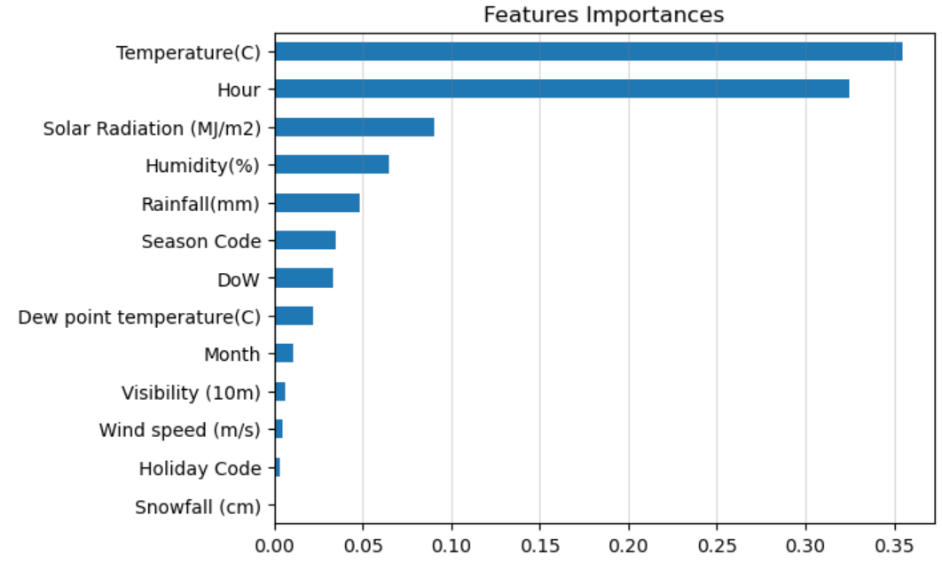
From this graphic, it is clear that the temperature & hour of the day are considerably more important in predicting the number of bike rentals. Snowfall, holidays, wind speed, visibility, & the month are the least important features. Features including solar radiation, humidity, rainfall, season, day-of-week, & dew point temperature have relative importance for this model, but they aren't the most important features.
Now that the machine learning algorithm used to create predictions has been decided, more models & predictions can be made & refined. As discussed in the analysis section, the model did not use the entire original dataset when the data was split into training & testing sets. This resulted in some missing rental bike values in the predictions. After merging the predictions with the original data, rental values that didn't have any corresponding predictions were left with null values. This merged dataset had 3038 rows, 924 of which had null bike rental predictions. Additionally, some rental bike values had multiple corresponding predictions. For example, the rental bike count of 62 corresponded to seven different rental predictions.
This dataset containing bike rental observations & corresponding predictions was evaluated to determine if & how much the data was influenced as a result of the merger. Reassuringly, the correlation between the actual & predicted numbers of bike rentals decreased by less than one ten thousandth. The merged data is plotted below, & it strongly resembles the previous scatterplot.
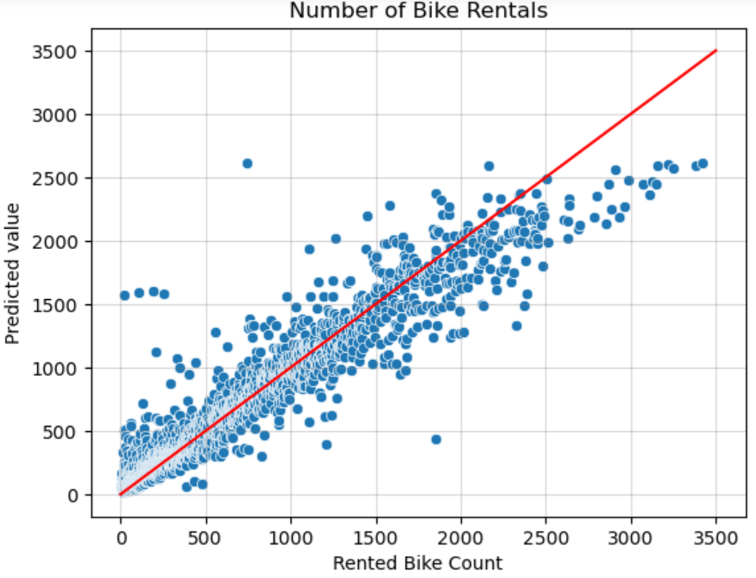
Once more, the predictions appear to overestimate the number of bike rentals at less popular times (about 0-1000 rentals) & underestimate the number of bike rentals at more popular times (about 1000+ rentals).
Additionally, the random forest regression algorithm was used to explore the data by season. Reasons for doing so included determining how a different sample size may influence the accuracy & performance of the predictions & eliminating a parameter from the predictor variables (season code) to see how the model would change. Additionally, splitting the data by season would narrow the ranges of the values of other parameters which could influence the importances of each feature in relation to the target variable (number of bike rentals) positively or negatively. The test sizes used for these four seasonal models was 0.25, as was the case for the previous model. The table below shows important metrics & summary statistics for each of the five random forest regression models to help compare them. The first model used the entire original dataset whereas the latter four models used smaller subsets of data depending on the season.

Statistic | Entire Data | Winter Data | Spring Data | Summer Data | Autumn Data
# Nulls / # Rows (null %) | 924 / 3038 (30.4%) | 243 / 783 (31.0%) | 830 / 1370 (60.6%) | 921 / 1473 (62.5%) | 786 / 1271 (61.8%)
Correlation | 0.953 | 0.909 | 0.933 | 0.949 | 0.949
Mean Abs. Error | 119 | 38.8 | 147 | 148 | 139
Root Mean Squared Error | 199 | 64.4 | 231 | 230 | 213
Model Accuracy Score | 90.6% | 81.9% | 86.7% | 89.9% | 89.5%

It is important to note that the ranges of bike rentals differ across these five datasets. As a result, the variance will differ & the values of these metrics will be influenced accordingly. This explains why one dataset may have a larger error & a larger model accuracy score.
From the table above, only the winter model had smaller errors than the model that used the entire data; however, the winter model had the lowest correlation & model accuracy score of any of the five models. Though the winter model had a smaller proportion of null predictions, it used less data than any other model. Regarding the other three seasons, their metrics are all inferior to those of the model that used the entire original dataset. The plots below display the data points for each season. Note that the range of bike rentals for the winter plot is considerably different than any other season.
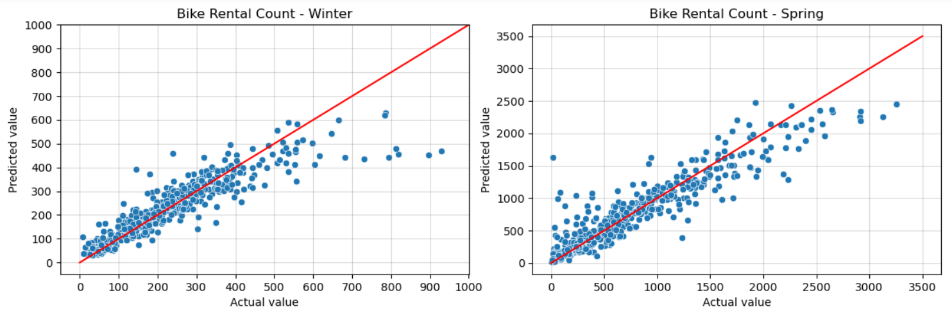
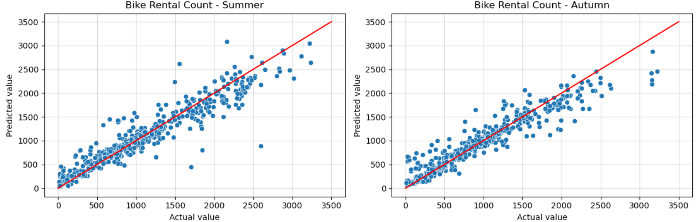
These plots display similar behaviors from a previous plot illustrating the model that used the entire data. For smaller values of actual bike rentals (less popular times), the predictions appear to overestimate the number of bike rentals. For larger values (more popular times), the predictions appear to underestimate the number of bike rentals. This can be seen in the plots by analyzing how many data points are above and below the red line. Though this behavior is fairly consistent across the four seasons, the amount of under- & overestimation differs slightly across the range of actual rental values. The plots below display the feature importances for each season.
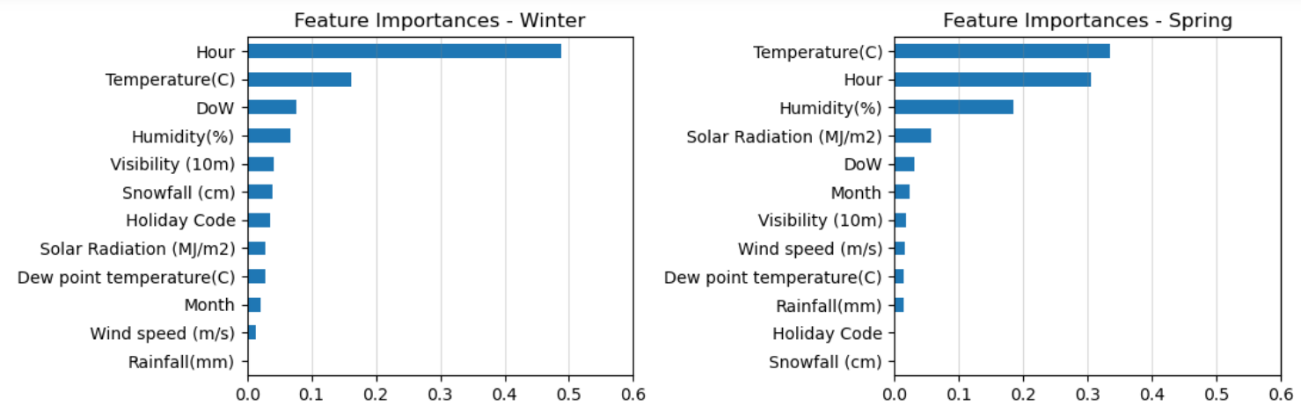
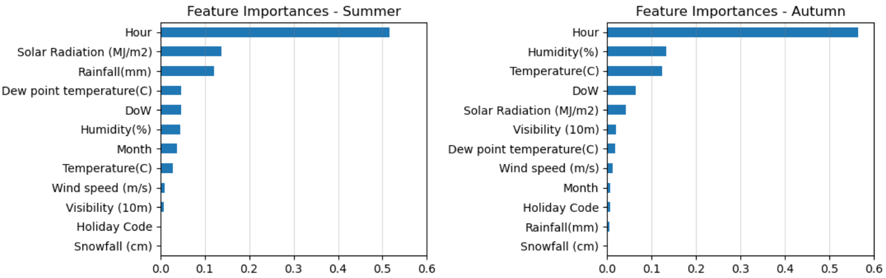
Across the four seasonal models, the most important features include the hour of the day & temperature. Humidity is also considerably important relative to many of the features. The least important features across the four models include snowfall, holiday, wind speed, month, visibility, & rainfall. Also, dew point temperature has little importance. Across the four seasonal models, the day of the week & solar radiation have some slight importance such that they are not negligible. Overall, these conclusions are quite similar to those of the model which used the entire data.
Throughout the analysis, there were multiple calculations that indicated that splitting the data by season produced models which were less effective when it came to predicting the number of bike rentals. Using metrics & other statistical calculations such as correlation, the model which analyzed the dataset as a whole – thereby incorporating the 'Seasons' variable – was more effective. For this model, the accuracy score & correlation between actual & predicted numbers of bike rentals was larger, & measures of error & total null values were lower. Proportionally, none of the four seasonal models performed better than the larger model regarding any of these measures despite having less varying & less complicated data to analyze. As such, the random forest regression model which used the entire dataset was deemed as the best method to perform predictions for the data regarding the number of bike rentals.

Enhancing & Organizing Prediction Data
In the project, this section sought to produce & define clearer predictions for the number of bike rentals. Firstly, the null & duplicate values/predictions needed to be dealt with. Realistically, predicting & producing the number of bikes that could possibly be rented at every hour of a day is extremely difficult, especially for such a large & diverse dataset. Instead of trying to predict a single value, a better solution may be to predict a range of rental counts that could potentially be rented during a certain hour, a period of a day, on a certain day, or some other period. With this in mind, the strategy that was used involved splitting the data into ranges of bike rental counts, aggregating corresponding predicted rental counts for these ranges, & calculating some summary statistics on these ranges of values such as the mean, minimum, maximum, & others.
The ranges of rental counts & how they should be split was decided by choosing optimal ranges that could provide enough specificity in the resulting predictions, yet also help sufficiently satisfy the objectives of the project. Recall that a challenge of the rapid yet fluctuating demand that the business encountered was that there were not enough available bikes on some days & too many on others. Ultimately, the goal is to be more precise in predicting demand, so using a smaller range would be more optimal as long as the predictions perform sufficiently well. From the dataset, as few as two & as many as 3556 bikes were rented at any time. As such, optimal ranges of rentals could be split by every 10, 50, 100 bike rentals or so. Using smaller splits would require more computational resources but doing so could be more accurate. Therefore, splits of 50 bike rentals were chosen & analyzed.
To get a sense of how these splits would segment the data in the actual data & predictions, some histograms were made. Shown below, the left-side plots show the actual data, & the right-side plots show the predictions. The top two plots count the number of instances of rentals for each range, whereas the bottom two plots measure these instances as a proportion. Note that the values of the vertical axes of the top two plots differ considerably since the predictions have fewer total observations than the original dataset. The bins of these histograms were split by 100 bike rentals. The red lines are kernel density estimation ("kde") lines which help illustrate & estimate the probability function of each set of data. Essentially, the lines illustrate the probability of a certain number (or range in this case) of bikes rentals occurring.
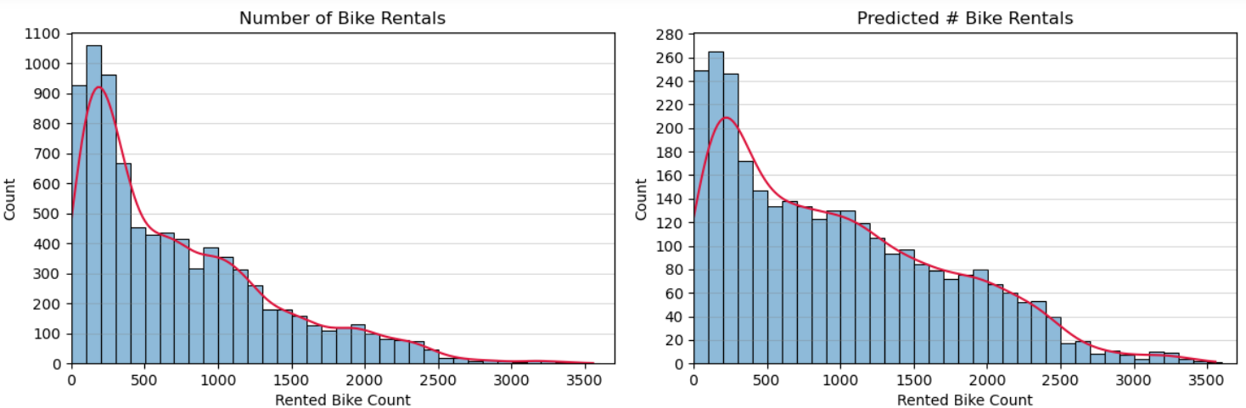
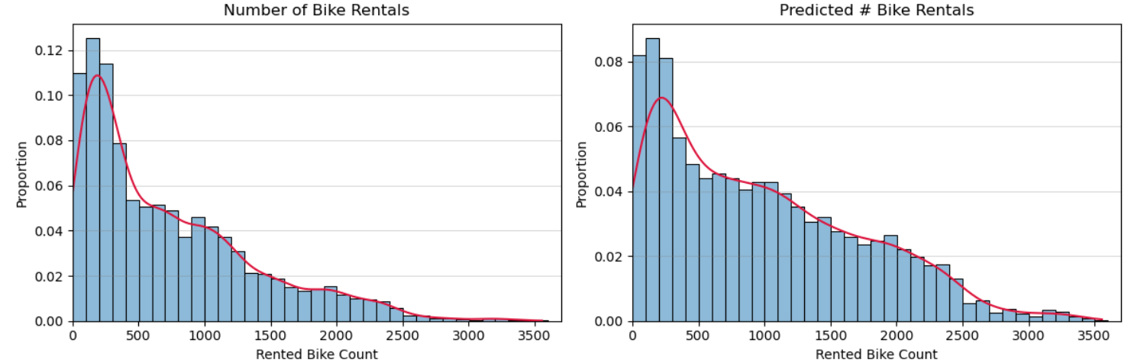
In comparing the frequencies of bike rentals between these two sets of data (based on the continuous, red kde line), there are notable differences depending on the rental bike count. For smaller numbers of bike rentals (about 0-500), there are more rentals from the original dataset than in the predictions. As the number of bike rentals increases, the frequencies between the actual data & predictions become more comparable. At about 1000 bike rentals, the frequencies are essentially equal (~ 0.40). By about 1500 bike rentals, the frequency of the number of bike rentals in the predictions is notably larger than that of the original data (~0.30 vs ~0.20). The frequency of the original data becomes essentially negligent by about 3000 rental counts, whereas the frequency of the predictions becomes similarly negligent at about 3500 rental counts.
These findings suggest that the predictions underestimate the number of smaller numbers of bike rentals (about 0-500) but overestimated the number of larger numbers of bike rentals (about 2000 or more). With this in mind, these narrower predictions may be more effective than the original data regarding one of the objectives of this analysis in wanting to avoid having too few or too many bikes available.
Recall that about a third of the rental counts from this model had null predictions. As a result, smaller ranges will be affected more because null values would be more likely to make up a greater portion of a given range of rental counts. For example, of the prediction data with actual rental counts between zero & nine, four of 12 observations (a third) were null. If the data were split into ranges of every 50 rental counts, of the prediction data with actual rental counts between zero & 50, six of 111 observations were null. This information suggests that using splits of 10 rental counts may be too comprehensive for the purposes of this analysis, which served as another reason as to why ranges of 50 rental counts were chosen.
In the merged dataset containing actual numbers of bike rentals & their corresponding predictions, the values were split into intervals for every 50 bike rentals; 0-49, 50-99, & so on up through 3550-3599 rentals. For each range, the actual & predicted number of bike rentals were analyzed & summary statistics were calculated. These statistics were compared to understand how the predictions fit the actual data & how to best utilize the predictions.
Ultimately, the mean of each range was used as the predicted number of bike rentals for said range; however, there were some null values in some ranges because there weren't any instances of certain numbers of actual bike rentals, or the predictions didn't produce any data of certain numbers of bike rentals. Of 36 total ranges of bike rentals in the dataset containing data from both the original dataset & predictions, nine did not have any data to perform calculations on, & so they had null values. Additionally, a column for each range of rentals was made to help evaluate the variance of each rental range's predictions. This column simply took the difference of the two means of the actual & predicted data for each range.
A plot was made displaying the average number of bike rentals for each of the two sets of data (original & predictions) for each range of 50 rentals. A dashed black line was also superposed onto the plot to help illustrate what a positive, perfectly linear relationship between the two axes would look like. This dashed black line served the same purpose as the solid red line in previous plots.
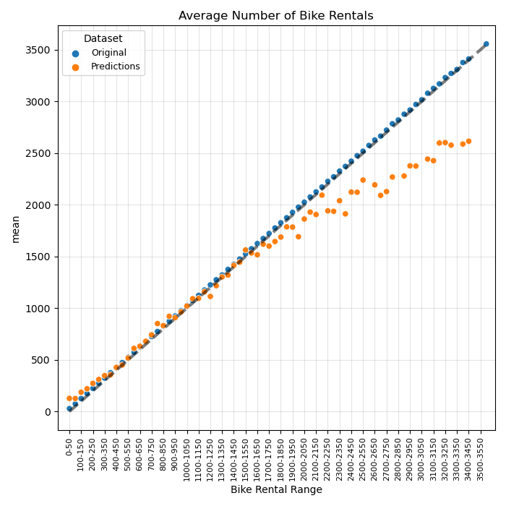
For smaller numbers of bike rentals (specifically about 0-400 rentals), the average number of bike rentals from the predictions is larger in the predictions than in the original data. The average number of bike rentals is similar across the two datasets in the lower-middle range of bike rental counts (approximately 400-1500). As the number of bike rentals increases, the average number of bike rentals across these ranges becomes considerably smaller in the predictions than in the actual data (approximately 2000+).
These findings support conclusions of previous discussions describing how the predictions underestimated & overestimated the number of bike rentals at different counts of rentals. Specifically, the predictions overestimate the number of bike rentals for smaller counts, & the predictions underestimate the number of bike rentals for larger counts.
At this point, the problem of null predictions could be solved more easily. In the predictions, there were seven ranges of 36 that did not have any rental data to perform any calculations on. A couple of different strategies were used to impute values for these null predictions. For ranges with no rental data that did not precede or follow another range with no rental data, the missing average was defined using the means of the two adjacent ranges. For example, the range of 2550-2600 rentals did not have any data to use, but the two immediately adjacent ranges (2500-2550 & 2600-2650) did. Therefore, the mean predicted rental count for this range (2550-2600) used the average of these two adjacent ranges' means.
Unfortunately, this technique was not applicable for every instance of null values in the data. Specifically, the last three bike ranges (3450-3500, 3500-3550, 3550-3600) had null values. For these upper ranges of bike rentals, more context is useful. In the original data, there were only three instances in which at least 3400 bikes were rented (3404, 3411, 3556). Of these three values, only one had a corresponding predicted bike-rental count (3418 had a predicted value of ~2615), which was the largest predicted rental count of the predictions. The box plot below, which illustrates the distribution of the predicted rental count, indicates that many of these upper values are considered outliers.
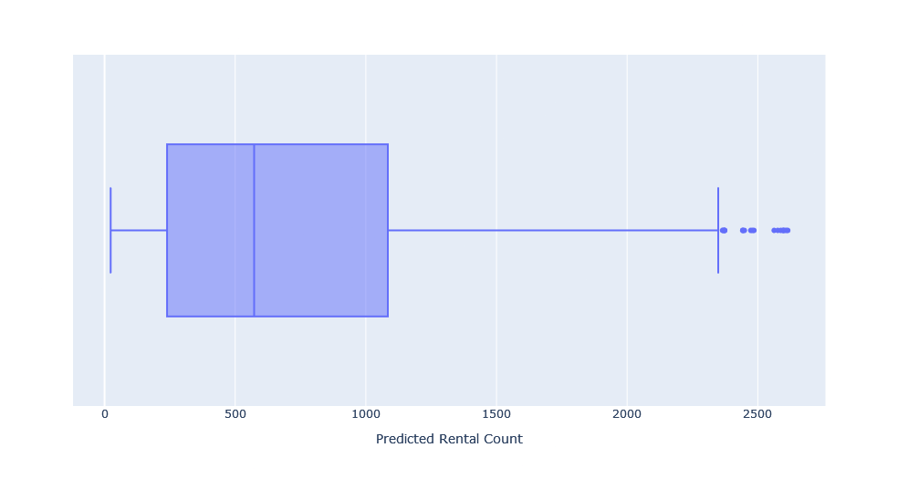
Essentially, there are so few instances in which at least 3400 bikes were actually rented that there aren't any such instances in the predictions. At this point, the difference between the actual & predicted number of rentals is so large that it is difficult to construct a credible bike rental count at these larger ranges. Additionally, these upper ranges also serve as an upper limit on the number of bike rentals both in the original data & predictions. Therefore, using the most recent predicted value, which is the largest predicted value, is the most representative method in predicting these upper ranges of bike rentals. As a result, the null values for these upper ranges of bike rentals (3450-3500, 3500-3550, 3550-3600) used the nearest & largest bike rental prediction of ~2615. Ultimately, only one observation in the original data was influenced by this.
After these ranges with null values were assigned new average rental counts, the averages were rounded up to the nearest integer because a bike cannot be fractionally rented. Then, these values were inserted alongside the original data in a new column that appropriately assigned the predicted rental value based on the actual rental value & what range it was in. At this point, the predictions were successfully made & organized alongside the rest of the original data. The predictions could then be analyzed with respect to the rest of the data to further evaluate their performance. The correlation was measured between the original rental count column & the new predicted rental count column which came out to about 0.997. Therefore, it can be concluded that using this technique of splitting the number of actual & predicted into ranges of 50 rentals is effective in constructing continuous numbers of rental predictions across the entire data range. Of course, smaller ranges of rentals such as 10 or 20 could also be analyzed & utilized in creating the bike rental predictions, but as mentioned previously, doing so would require more memory & computational resources.
With the predictions finalized, each parameter was analyzed with respect to the two rental bike counts: the original data & predictions. Plots were made & consistent patterns were observed that were similar to previous plots. Specifically, the range of the predicted number of rentals was smaller than what was observed in the original data. Once more, the predictions seemingly overestimated the number of rentals for smaller numbers of actual rentals, & they underestimated the number of rentals for larger numbers of actual rentals. For clarity, the number of actual rentals was within about 0-3600, whereas the number of predicted rentals was within about 100-2600.
Regarding the business' problem of having too many bikes on some days & not enough on others, the aforementioned pattern may help because it provides a narrower range of predicted rentals. It would help prevent not having enough bikes available for smaller numbers & having too many bikes available for larger numbers. On the other hand, it would not help to prevent having too few bikes for larger numbers & having too many bikes available for smaller numbers. Given that an overall objective of the project was to create predictions that are more precise than the original data, this narrower range of predictions lessens the amount of variance in the number of bike rentals, thereby increasing precision. Ultimately, the main goal of these predictions is to increase precision to better meet bike rental demand while also not tightly limiting the window of available rentals in case the business continues to scale upwards. Through the analysis & the results collected in the project & report, the predictions that were created were deemed to be sufficiently effective regarding these goals.
The last section of the project describes how to use the data, which at this point now included rental predictions, to predict the number of bikes that are recommended to be made available to rent. Essentially, the parameters in the data can be filtered based on known or forecasted information (such as the hour, time of year, weather, holiday, etc.). Doing so will help narrow down which previous observations comply with these filters, provide details of such rentals that were placed previously, & how many bikes are predicted to be rented based on the results of the model.

Conclusions
Recall the goals of the project. The primary objectives included:
- Determine if the number of bike rentals can be predicted based on other information in the dataset.
- Create predictions for how many bikes will be rented & analyze their credibility & accuracy.
In this analysis, multiple models & predictions were created using different machine learning algorithms & approaches. Linear regression & random forest regression algorithms were used to create models. They incorporated several of the parameters defined in the original dataset. Furthermore, the random forest regression technique included a model which analyzed the entire dataset & four other models which analyzed the data by season.
Ultimately, the random forest regression technique proved to be considerably more effective in calculating predictions of the number of bike rentals. In analyzing the dataset, the linear regression model had an accuracy score of about 55%, whereas the random forest regression model had an accuracy score of about 91%. One key example of the ineptitude of the linear regression model was that it predicted that there would be negative numbers of bike rentals more than 100 times which is not possible. The random forest regression models did not have any such predictions. As a result, the linear regression method was disregarded, & further analysis continued to explore the random forest method.
Furthermore, the random forest method was used to explore other approaches. In addition to the random forest model previously created, four additional models were made for each of the four seasons using subsets of the data based on the season. Throughout the analysis, there were multiple metrics that indicated that splitting the data by season produced models that were less effective when it came to predicting the number of bike rentals. Such calculations included measures of correlation, model accuracy, & error. The values of these metrics for each of the five random forest models can be referenced in the table above. Given the quality of these values, such as a model accuracy score of about 90%, the random forest regression model that used the entire dataset was deemed sufficient enough & the most suitable method to perform predictions for the data.
The predictions from this model were cleaned up by splitting the data into ranges based on the number of bike rentals. Summary statistics, such as the mean, were calculated for each range. Ultimately, goals of these predictions included the desire to increase precision but not sacrifice the business' ability to adjust for fluctuations in the demand of bike rentals. Therefore, these ranges of bike rentals were split by 50, resulting in 36 total ranges.
Analyses of these predictions came to consistent conclusions in how they were related to the original data. Specifically, for smaller numbers of rentals (less popular times), the model overestimated the number of rentals. For larger numbers of rentals (more popular times), the model underestimated the number of rentals. Given this & the performance of the model, it was concluded that using this technique of splitting the number of rentals by every 50 rentals was effective in constructing representative rental predictions for the dataset. Also, these constructed predictions can be useful in projecting future counts of bike rentals because of the preceding evaluation, & how they help better prevent having too little or too many bike rentals available.
The predictions were finalized & imputed into the original dataset. By filtering other parameters in the data, numbers of predicted rentals can be determined & used to recommend how many bikes should be made available for rent at a specific time.

Additional Notes
In the python notebook, the relevant analysis is in the "Analysis IV" section which starts at about one-third of the way into the notebook of the project.
This link contains the source of the dataset. The python notebook is contained & accessible in the folder which also contains this Word document. The python notebook is an HTML file titled "Python Notebook – Bike Sharing Demand Data."

Citations
AnalytixLabs. (2023, December 26). Random Forest Regression - How it Helps in Predictive Analytics?. Medium. https://medium.com/@byanalytixlabs/random-forest-regression-how-it-helps-in-predictive-analytics-01c31897c1d4.
Beheshti, N. (2022, March 2). Random Forest Regression. Medium. https://towardsdatascience.com/random-forest-regression-5f605132d19d.
Sathishkumar V E, Jangwoo Park, and Yongyun Cho. 'Using data mining techniques for bike sharing demand prediction in metropolitan city.' Computer Communications, Vol.153, pp.353-366, March, 2020.
Sathishkumar V E and Yongyun Cho. 'A rule-based model for Seoul Bike sharing demand prediction using weather data' European Journal of Remote Sensing, pp. 1-18, Feb, 2020.

